Sally Chicane Headline Inaugural She-Riff: A Night of Women in Rock

With so many talented female musicians in Canberra, local musician Kristy Anderson came up with the concept of “She-Riff”, a gig with a line up of female bands and artists.

Anderson is the vocalist/guitarist of Sally Chicane, who have just released their debut EP “Consumption”.

Affectionately named after the Magic Dirt track, “She-Riff” is a gig featuring Canberra women of rock playing original material.

The first gig will showcase soloists Betty Marshall and Adelaide Jones, and bands House of Strangers and Sally Chicane. We are grateful for the support of the Transit Bar in providing a venue for “She-Riff”.

We welcome other female performers to get in touch if they would like to play on a future “She-Riff” gig, with the next gig planned for September. The gigs are open to any female soloists or groups playing predominantly original material. Groups must feature a female member in a prominent role.

On July 21, Sally Chicane will headline “She-Riff” at the Transit Bar, Canberra ACT with House of Strangers, Adelaide Jones and Betty Marshall. Entry is $5 and the night kicks off at 8pm.

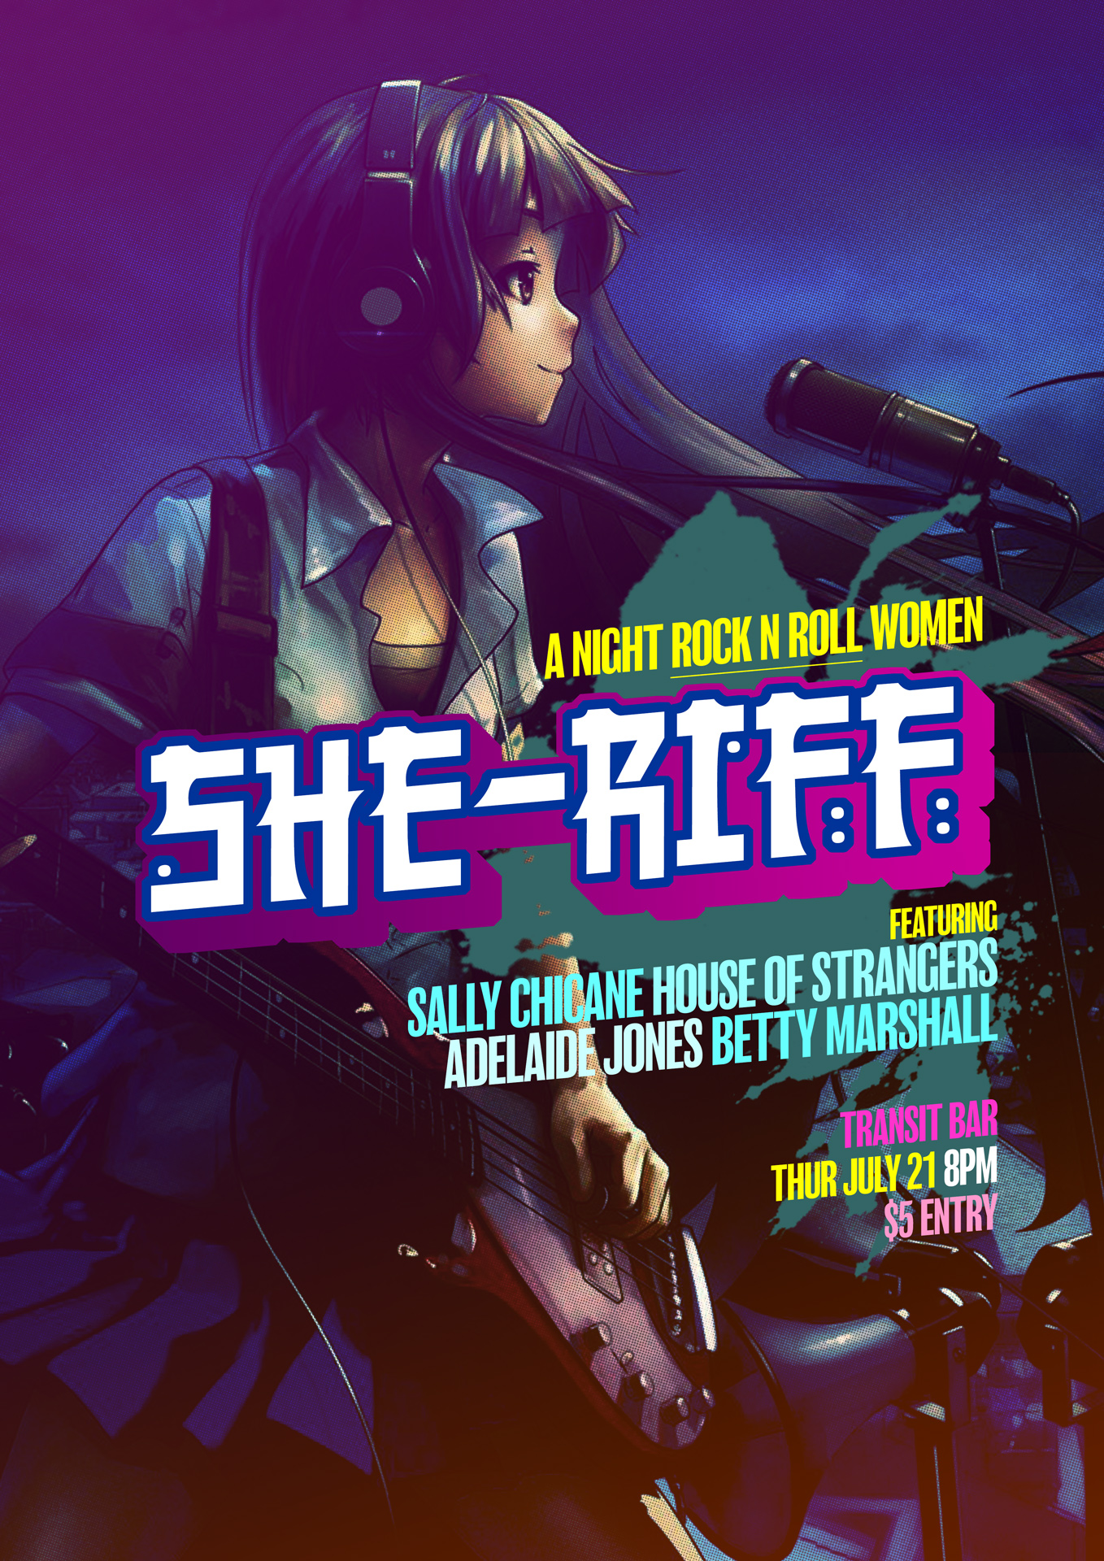

Electronic version of this press release and high resolution band photos at:
http://www.sallychicane.com/#!press/b4xbh

For more information contact: sallychicane@gmail.com, facebook.com/sallychicane or call Kristy on 0422 055971

